Patterns

Patterns Architecture 3
About This Document 3
Definitions 3
Architecture 4
Overview 4
The System’s Components 5
The patterns Component 5
The patterns_gui Component 6
The User-Interface Component 6
The SignalProcessing Component 7
Adapters 7
The CALM Adapters 8
User Interface 8
Installation 9
Patterns products and tools 10
Patterns client vs. Patterns server 14
Patterns clients attached to a Clinical Client 15
Debug keys 16
Appendix 17
Appendix 1: architecture graph 17

Patterns Architecture

About This Document
This document aims at giving the reader a basic understanding of the Patterns project, as well as an insight into the design philosophy behind the development and architecture effort as of January 2009.

The aim is not to explain the business case for the software nor is it our purpose here to educate about decision support or what it is exactly that Patterns does. The reader is expected to have at least some degree of understanding of the context in which Patterns is expected to be used and of what event and contraction detection means.

The Architecture section presents a detailed overview of the actual software development effort in light of its original goals. The various software components that make up the system and the classes they are built with are documented from an architectural point of view, that is, this document does not include a comprehensive reference guide for developing client code or for modifying or extending the system’s functionality. As stated below, the source code itself is intended as reference documentation.

The User Interface section goes on to describe the elements that are presented to the user and the design philosophy and usability concerns that motivate the choices made. It explains the high-level workflow that is proposed to the user and the way the system is expected to be used. In addition, ideas for user-interface enhancements are briefly sketched out to better illustrate the design’s purpose.

Finally, the installation process is explained in the context of the architecture and user-interface design choices.

Definitions
Client
In the context of a specific component (i.e. a namespace, class, method or function), the word “client”, relatively speaking, is taken to mean another component that calls it synchronously or that gets called by it asynchronously after having registered.
Component
The word “component” has two different meanings throughout the document and they should be clear from the context. Strictly speaking, the word is used to designate a C++ namespace and all classes and functions it contains. The words “component” and “namespace” are thus used interchangeably. In some instances, however, the word is used to designate a generic code fragment, that is, a function, operator, method, class or namespace, when describing interactions between the various pieces of code that make up the system.
Events
Designates all output of the SignalProcessing component, namely, baselines, accelerations and deceleration. It is strictly equivalent to the word “features” in the context of Patterns. The word “event” is used throughout the code, for instance, in the patterns :: event class and in methods like patterns :: fetus :: get_number_of_events ()

Features
See “Events”.

Patterns
In this document, Patterns designates the Windows application being developed around the “Patterns” project. Other entities frequently referred to as Patterns and fully qualified here to avoid confusion. The central component itself is called the patterns component, the outsourced Patterns engine is called the SignalProcessing component and Patterns as a research topic is not mentioned.
Software
See “System”.
System
The Patterns software, application or executable is referred to as “the system”. The term is used interchangeably with the other terms mentioned above. In some instances, it also refers to a given collection of executables co-operating to perform distributed computing.

Architecture

Overview
The Patterns system is architected with extreme versatility, reusability and portability in mind, and was designed from an algorithm-centric perspective. It is built around the patterns component (see Architecture de Patterns in appendix), which holds all the algorithms and abstract data structures involved in event and contraction detection, and which depends on no other component. The user-interface and patterns_gui components are designed as client components of the central patterns component.

All design decisions were made with reusability in mind: mainly, the patterns component or any of its parts or classes is easily compiled into any project. Other important concerns include abstracting the system of business-driven decisions.

Furthermore, the patterns_gui :: tracing and patient_list classes are meant to be reused outside of the Patterns-related context. Specifically, Patterns’ tracing control is a fairly complete and capable one and could easily serve elsewhere as a generic fetal-heart-rate (FHR) or uterine-pressure (UP) tracing control.

The System’s Components
As stated above in the Definitions section, except for the user-interface component, components are implemented as C++ namespaces, and the terms are used here interchangeably.

The patterns Component
The patterns namespace’s main entry points for client components are the conductor and fetus classes. Although the fetus class can be used without it, the conductor class is the component’s maître d’. It creates fetus instances and directs data to and from them, deciding when to launch detection and cooperating with other instances of Patterns, through its adapters to the outside world.

The fetus class encapsulates all data in real time and may at the client’s or at the conductor’s request, trigger event and contraction detection. The class also supports importing and exporting its data to and from a number of compressed and uncompressed formats, including XML.

Client components, if they wish to use patterns as an integrated, automatic system, need to subclass and provide instances of the input_adapter and output_adapter classes to their instance of conductor. These adapters are the component’s interface for synchronous (outbound) and asynchronous (inbound) interaction with client components.

Client components wishing to be notified of events generated by the conductor and fetus instances need to subclass and provide instances of the subscription class. Only then will they get notified when a patient gets added to the list or when a deceleration or contraction is detected. This is primarily useful to UI components but is also of interest to classes implementing distributed computing outside this component.

The compression and contraction_detection classes are algorithmic classes, the former encapsulating tracing compression for FHR, UP or any other such data.

The samples class creates fetus instances, complete with raw data and results. It is used for unit-testing and for development purposes. It is useless but harmless in a deployment version.

Ths patterns component is client of C++’s Standard Template Library (STL) and of the SignalProcessing outsourced component, which is homologous to contraction_detection for event detection. See note below about the SignalProcessing component.

When compiled as is, the component is not a client of SignalProcessing and will not perform event detection. To add detection support, patterns code must be compiled with the preprocessor switch patterns_has_signal_processing defined. This makes it easier to utilize patterns without having to carefully tune compiler settings to get the SignalProcessing component to compile and link.

The patterns_gui Component
The patterns_gui namespace is a collection of reusable controls and services that are used to display patterns data. It is a client of the patterns component and of the Microsoft Foundation Class Library (MFC) framework.

The component provides the tracing and patient_list_control classes. A services class for painting alpha-channel bitmaps and for other such functionality is also provided.

The tracing class is a CWnd-derived tracing control for displaying FHR, UP and decision support-related results like contractions, events, variability, contraction rate, etc. The class takes its data from an associated instance of the fetus class, both synchronously and asynchronously, by subclassing the subscription class. In order to make the class more useful and readily usable, it is built to either manage its own instance of fetus or use a reference to a client-owned instance.

The patient_list_control class is a CListCtrl-derived control for displaying a patient list. The class takes its data asynchronously from an instance of conductor, by sub classing the subscription class. It will support several modes for displaying instances of the fetus classes, with or without thumbnails. It also supports an extensible filtering mechanism that clients may use to filter out patients according to any relevant criteria such as name, date of birth, status, etc. Clients need only supply an instance of a subclass of the patient_list_control :: filter class.

The User-Interface Component
The Patterns application per se is a classic MFC application where, as may be expected, everything is initiated by the singleton instance of the CWinApp-derived patterns_application class. It is that class that instanciates the conductor class and supplies it with instances of subclasses of the input_adapter and output_adapter classes. Patterns’ adapters are discussed below.

The User-Interface (UI) component is not designed to be reusable and is not encapsulated in a namespace. All reusable logic is encapsulated either in the patterns or patterns_gui components and the rest is closely related to Patterns’ nature as a Windows application.

The two most important classes of the UI component are the patient_list_view and patient_view classes.

The patient_list_view class simply wraps the patient_list_control class to make it more palatable to MFC’s view architecture, adding UI support for filtering and choosing display modes along the way. Through patterns_application, it directs the patient_view instance to display the currently selected patient.

Similarly, the patient_view class essentially wraps a CView around a tracing instance, also adding support for user-selected view modes.

The SignalProcessing Component
The SignalProcessing component is where the magic happens, in a sense, even though it is completely hidden from clients by the patterns component. It was developed by Evonium, a subcontracting firm, from a MATLAB prototype developed in-house.

The component may be used either off line, that is, feeding it the entire data set before launching detection, or in real time. The patterns component uses it in real time, providing it the data as it gets it from its instance of input_adapter or from fetus’ clients.

The component launches a worker thread as needed for performing detection without blocking the main UI thread. As a consequence, results are sent to fetus and to any subscription instance in the context of a separate, non-UI thread, and clients of the patterns component must be careful to avoid race conditions.

A reliable way to ensure the client code is thread-safe is to defer whatever should be triggered by the new results until the main UI thread gets there, for instance, by calling CWnd :: Invalidate () instead of RedrawWindow () or by raising an internal flag that will trigger getting the new data as needed at a later time.

Getting the SignalProcessing component to compile at all may be a serious endeavour and the reader wishing to incorporate it in his project is advised to take a close look at the projects that utilize it: Patterns Tool, Patterns Development, Patterns Application.

Adapters
As noted above, the patterns component communicates with the outside world through its input_adapter and output_adapter classes. Client components are expected to supply their instance of the conductor class with instances of subclasses that perform the effective work, calling back conductor and fetus asynchronously. This makes it easy to design and develop simple and interchangeable building blocks for applications that may need to store data in multiple database-like repositories, or that may need to connect to several data sources, systems and monitors, possibly concurrently.

As of January 2009, the Patterns application supports two sets of adapters: one for connecting directly to CALM and the other sample data (from in files or xml files).
The CALM Adapters
The calm_input_adapter and calm_output_adapter classes both sit on top of the LMSSite :: Client class in the CALM code base. They live in the LMSBroker world as do all CALM applications. They listen to messages broadcast by the broker and feed the conductor’s fetus instances with the data they are given. Similarly, they query the client’s cache and respond to broadcast messages to help the conductor maintain its list of currently admitted patients.

A mundane but major drawback of this implementation is that Patterns will not so much as launch if the CALM dynamic-link libraries (DLLs) are not properly installed. The main benefit, on the other hand, is immediate availability.

User Interface
The User Interface (UI) of the Patterns application is designed to be seen by the user as a single-purpose, single-window tool. It behaves like a control panel rather than a document-centric application like Microsoft Word, or rather than a platform-like environment such as the CALM Client (CC) itself.

Strong emphasis is put on instant access to meaningful data in a stable UI. The UI design is aimed at providing medical personnel with a quick overview of many patients’ status, ideally without having touched the mouse or keyboard. More detailed but equally instant data should be available by simply browsing the patient list, either through the keyboard’s arrow keys or by single mouse clicks.

The Patterns screen has two essential parts: the patient list and the current patient view. Additional controls surround the screen for displaying and configuring less-important data and settings.

The current patient view is the heart of the system’s UI. It displays a compressed view and a realistic, paper-like “expanded” view. The compressed view adds separate graphs for contraction rate and variability. Display modes include hiding additional compressed graphs or hiding the expanded view.

Both the expanded and compressed views show detected contractions and events (features) and let the user select and modify them. Selection is designed for easy inspection of objects without rendering the whole tracing harder to read. Similarly, the compressed view’s sliding window, analogous to the expanded view’s object selection scheme, is designed to clearly show the expanded view’s position, while at the same time presenting an unobstructed tracing for the user to review.

Installation
Installation issues are a special concern in designing and developing all components of the Patterns system, the goal being a zero-configuration, zero-installation application. Of course, the typical Patterns scenario implies installing CALM on every workstation the application runs on. However, Patterns requires no additional configuration, DLL or COM server to run.

Assuming that CALM is already up and running on a given workstation, installing consists in a single drag-and-drop operation. Patterns may even be put on and run from a network volume, thus requiring no installation whatsoever.

Zero configuration implies many things. For one, we refrain from using DLLs and choose to link with static libraries instead. Apart from saving the user from so-called “DLL Hell”, this makes the application more robust and less vulnerable to version issues. For instance, since the MFC libraries are statically linked, the application does not depend on a specific version of the MFC DLL being present. Also, the SignalProcessing component, which normally requires installing topologies as separate files, is used in such a way that all topology data in stored in resources. That has the added benefit of protecting that data from being tampered with, intentionally or not, by users.
The only configuration requires is on the Patterns server, upon installation the file pattern.config must be manually adjusted to reflect the customer's choices (some features can be turned on or off and some features can be configured). This is done once and only on the server, all Patterns client will use these settings automatically.
Sample of configuration file
contraction_rate_stage1_threshold = 3
contraction_rate_stage2_delay = 5
contraction_rate_upper_limit = 10
contraction_rate_window = 10
display_baseline_variability = true
display_classification = true
display_events = true
display_mhr = true
display_wcr_tracing = true
enable_ADT = true
enable_montevideo = true
event_detection_purchased = true

Patterns products and tools
As of January, 2009, four Patterns applications have been implemented:

CALMPatternsServer.exe
This is the patterns server, installed once per hospital, this is the application that will calculate all events and transfer the pattern data to the clients.

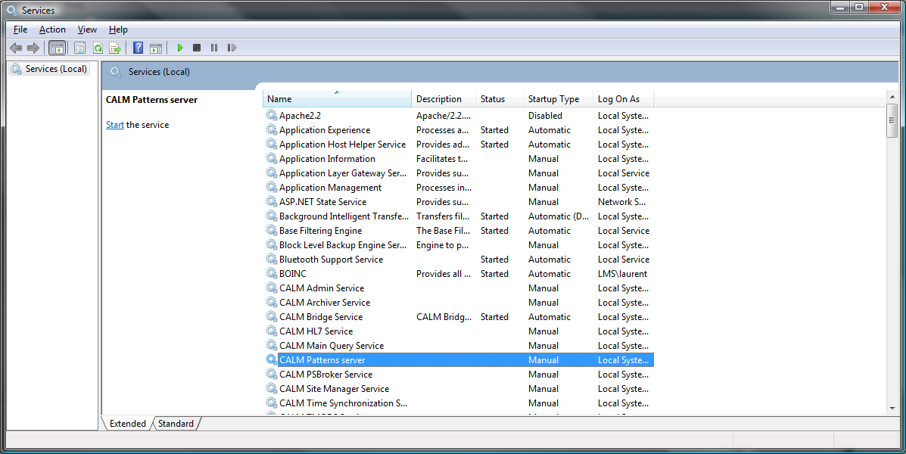

CALMPatterns.exe
This is the typical patterns application used by end user. It’s a viewer that can be installed on multiple workstations. It retrieves the clinical data from the CALM servers and the pattern data from the Patterns server.

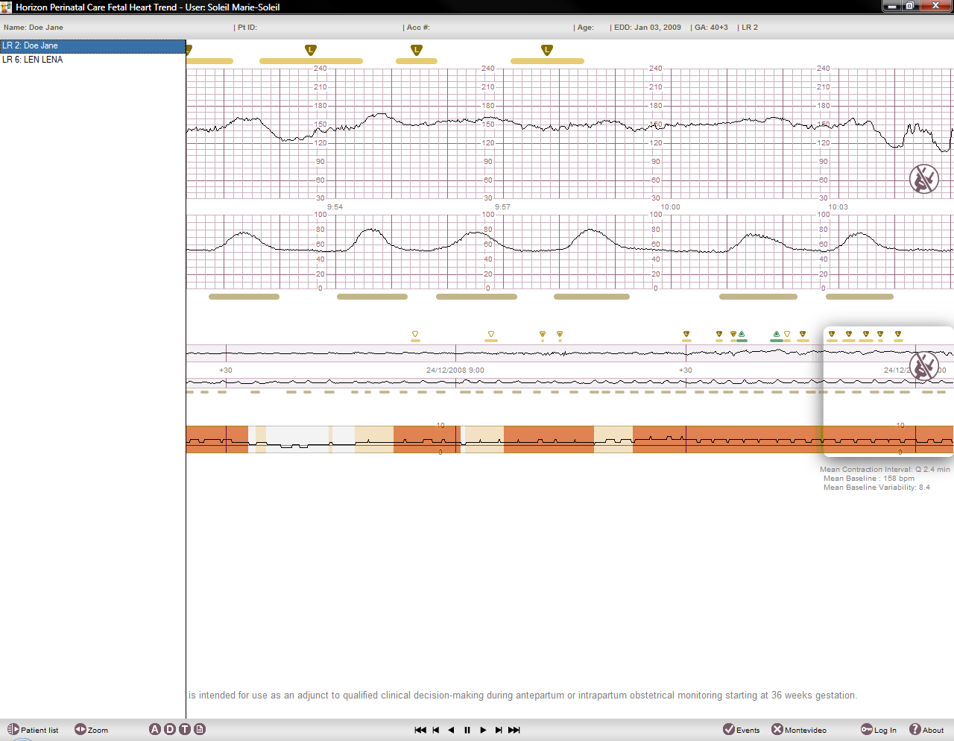
CALMPatternsViewer.exe
This is a simple patterns viewer, it can not perform detection but can be used to open and display a file. If this file contains events or contractions, they will be displayed.
There is no patient list and it can open only one file at a time (a browse file dialog is opened automatically when that application is started).

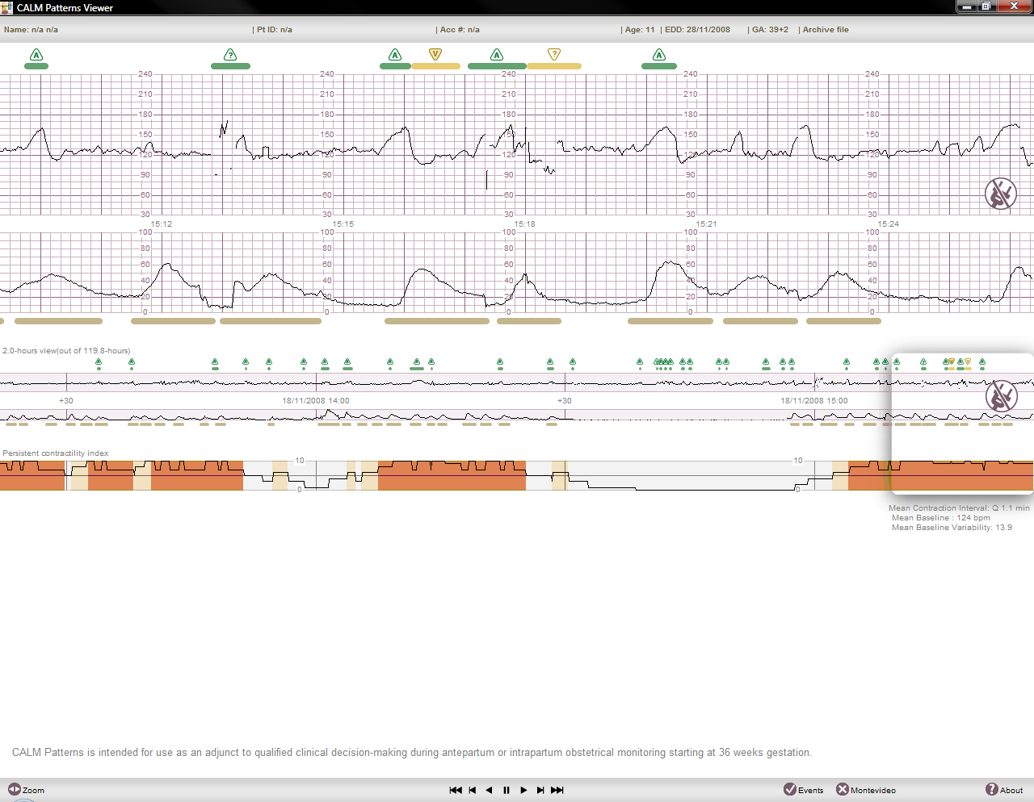

CALMPatternsDemo.exe
This is a demo version of patterns. At startup, it contains a set of typical tracings with there events and contraction. It can also open and display files (exactly like CALMPatternsViewer.exe)
This application contains a standalone event detection meaning that it can be used to calculate events without a server.

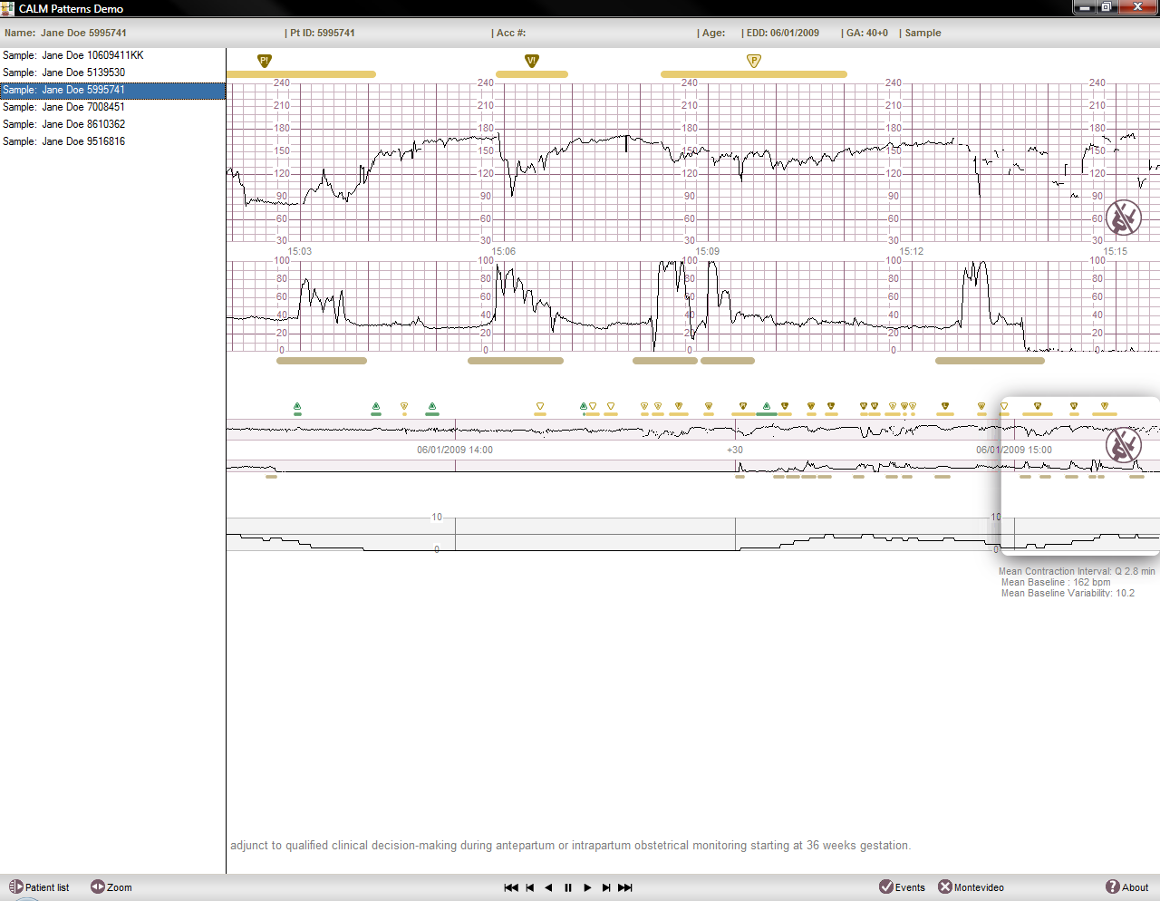

For intellectual property protection, this application is protected and will only run for a certain period of time (120 days). Past the fixed limit, it will refuse to start.
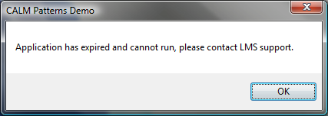

Some patterns tools are also available for development and testing purposes.

Patterns Test.exe
This application allows calculating events as if the tracing was coming in real time. It can also accelerate the speed, and multiple parameters can be modified to tweak the event detection. Also, it allows comparing different event sets.

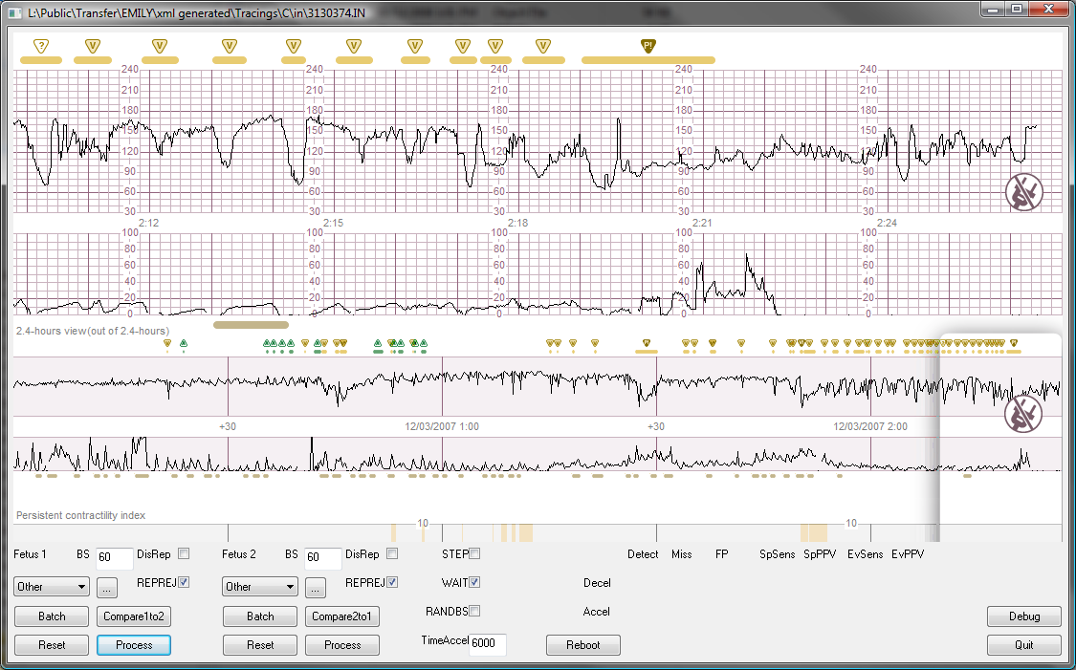

Patterns Console.exe
This is a non interactive console application that can calculate event for input files and save the results in files.

Patterns Compare.exe
This application is a non interactive console that will calculate event detection performances based on reference event detection.
It will produce statistical output that describe how good or bad the engine performed compare to a reference detection done manually by one or multiple clinicians.

See R&D team for more details about these tools.

Patterns client vs. Patterns server
The Patterns server is packaged as a service using an application named “ExeToService”. The role of CALM Patterns service is to start CALMPatternsServer.exe (hidden).
Since CALM Patterns needs CALM services to run, CALM services MUST be started before starting CALM Patterns service.
Even if we see in the services list that CALM Patterns service is started, this doesn’t mean that the CALM Patterns application is started.

To verify if the server is running, use the application Process Explorer. CALMPatternsServer.exe must be seen under CALMPatterns_serv.exe service.

Patterns clients attached to a Clinical Client
From the Clinical Client, the user can start a Patterns client. When started that way, this client behaves differently:
- no patient list
the patient currently selected is the one selected in the clinical client. If the user selects another patient in the clinical client, then the Patterns client will also display that same patient.
- no login / logout option
the user currently logged in into the clinical client is also logged in Patterns. If the user logs off in the clinical client, he also logs off in the Patterns client.

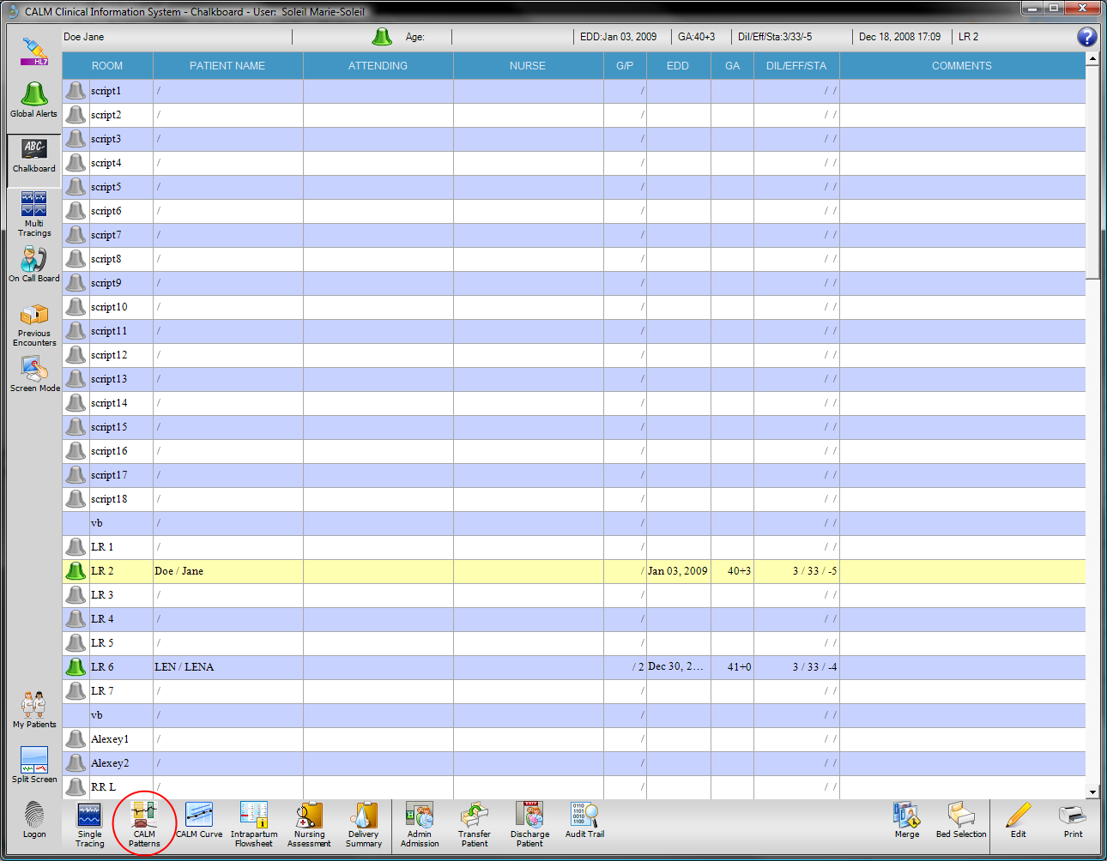

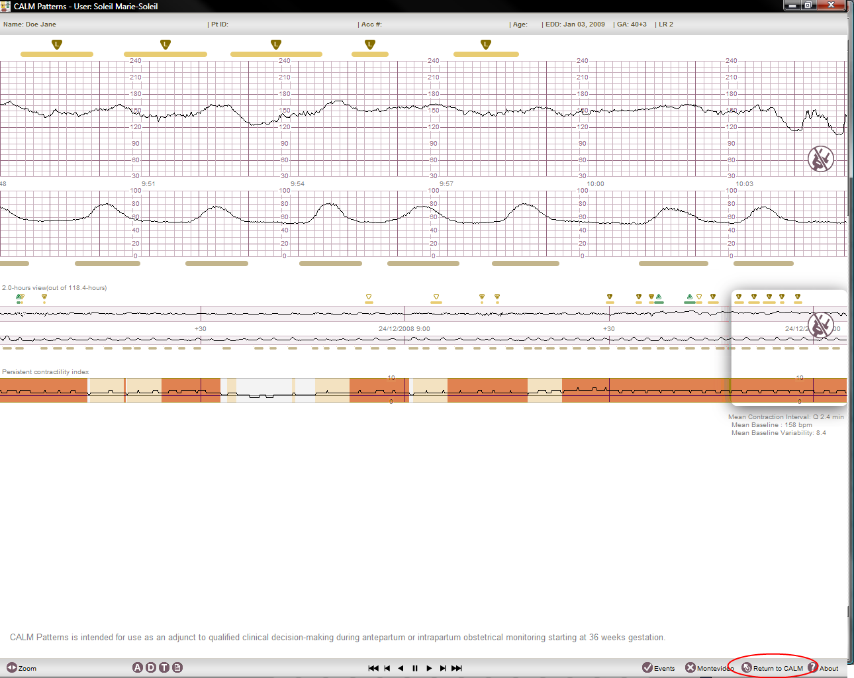

Debug keys
Debug keys have been added to the tracing control in order to facilitate de development and the debugging. These keys are available by pressing CTRL+ALT+SHIFT+D keys. A full list of debug keys and debug information will be displayed on screen by pressing the D letter (you must give the focus to the tracing control first).

Appendix

Appendix 1: architecture graph
